CRISP WORKSHOP BALLOON DATA ACTIVITY
Name:_______________________________________________________________ Date:______________
Lab Partner:_______________________
- Open Excel and open NGSS SEP Workshop Final.xls
- Select the tab “Exercise 1 – Balloon Data”, you should see the following data/table:
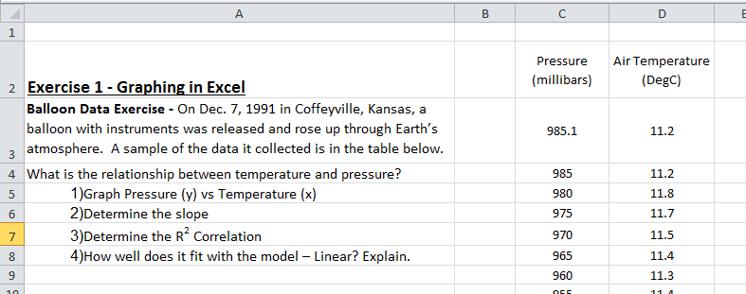
- Select the “Insert Tab” at the top of the page and select “Scatter Plot”
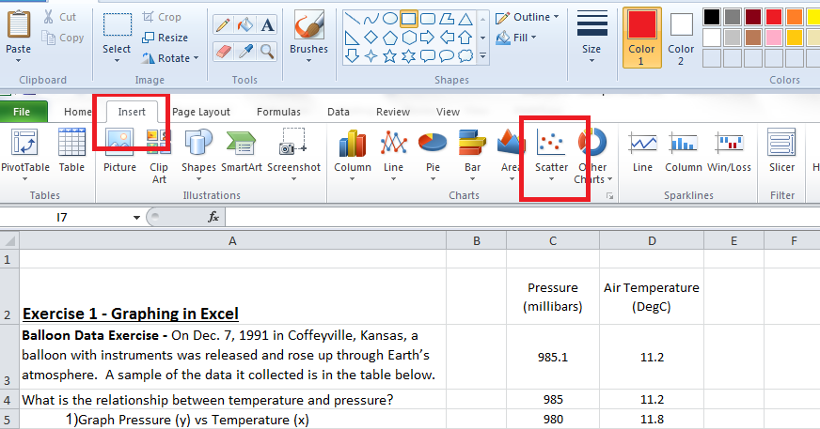
- Select the top left graph with only the data points. We can add lines later.
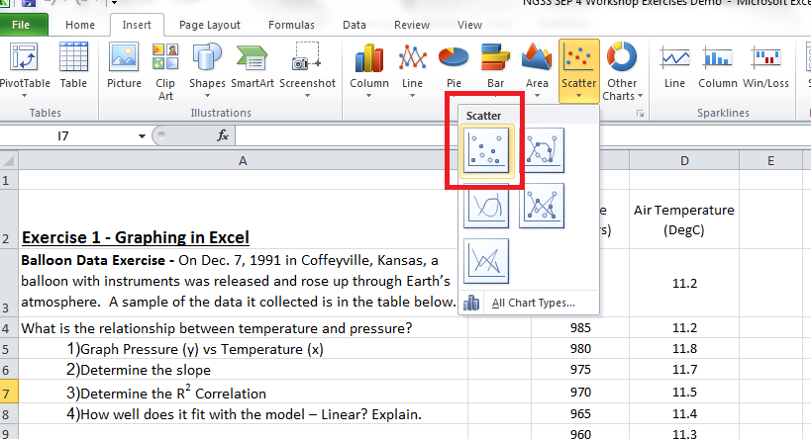

- Move the blank graph off of the data and to the side.
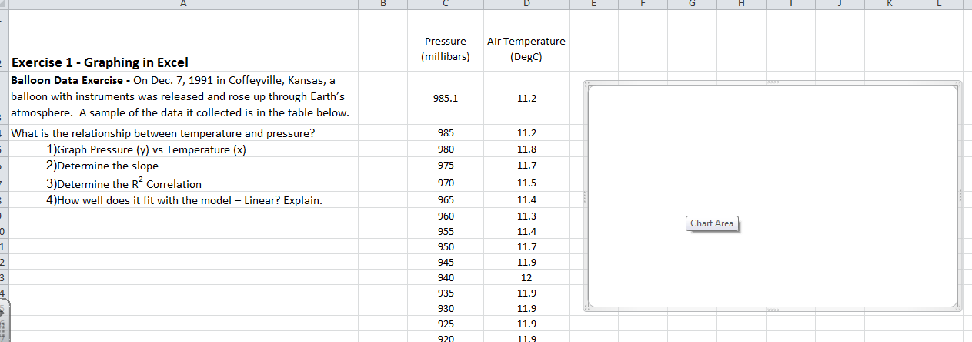

- Right click on the blank graph and select “SELECT DATA”.
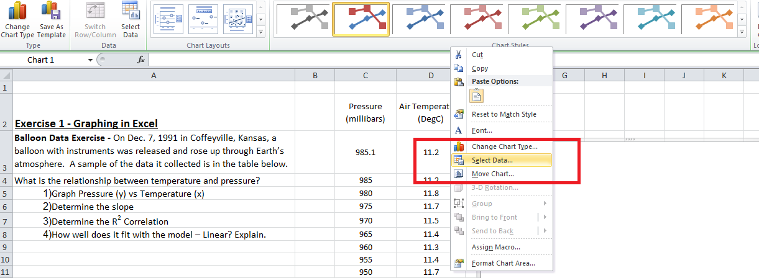
- Click on the button “ADD”. This allows us to choose the data to add to the chart.
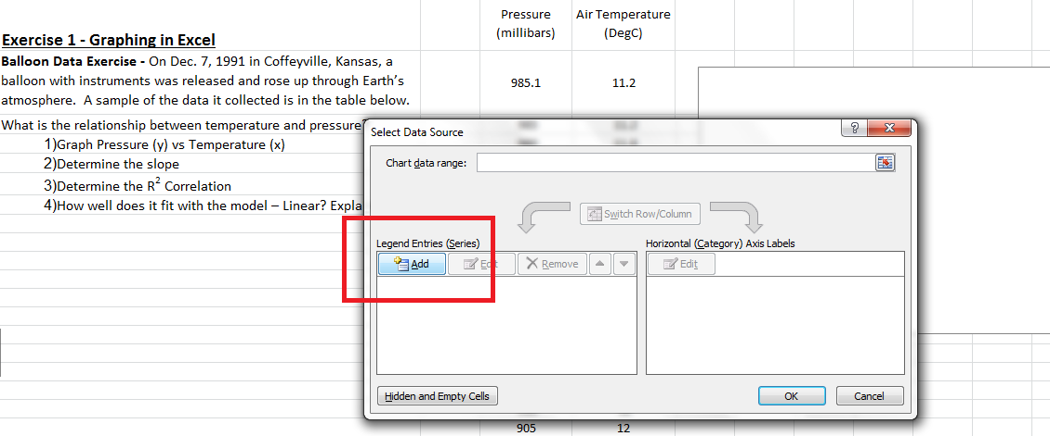
- Series Name will display the name of the trend line. Put “Balloon Data Dec 1991”.
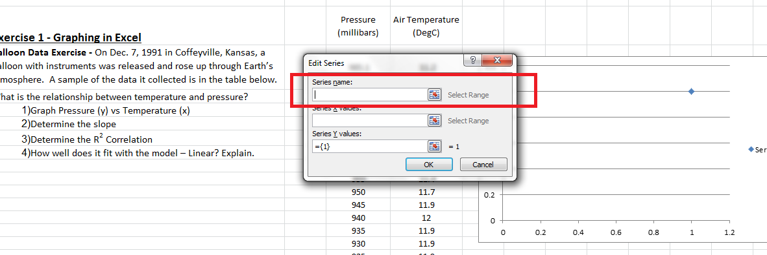
- Series “X” values will plot the data on the x-axis. Select the button 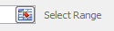, starting with the numbers (do not select the title), select and drag all of the numbers of the temperature data.
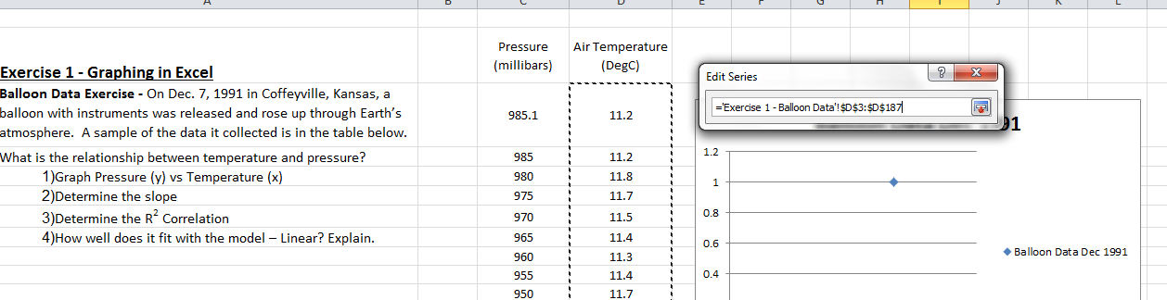
- Once the data is highlighted, click the button to finalize the selection.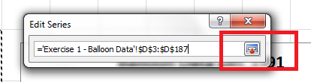
- Series “Y” values will plot the data on the y-axis. Select the button , starting with the numbers (do not select the title), select and drag all of the numbers of the pressure data.
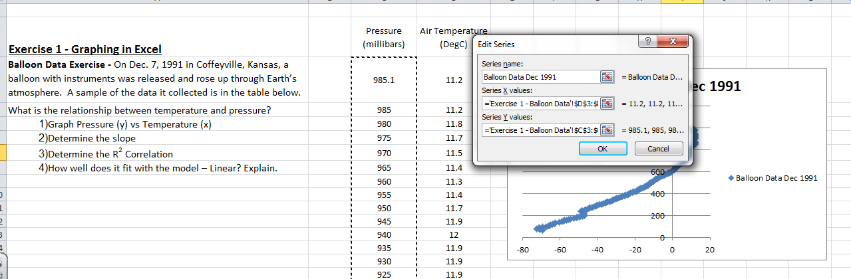

- Once the data is highlighted, click the button to finalize the selection.

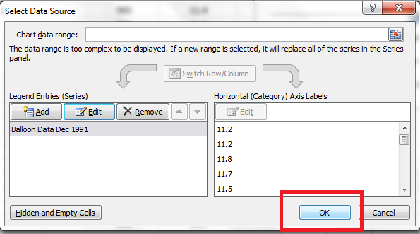
- Select OK, and then OK to display the graph on Excel.
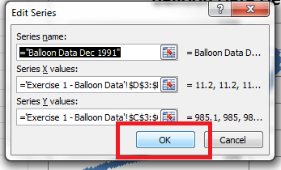

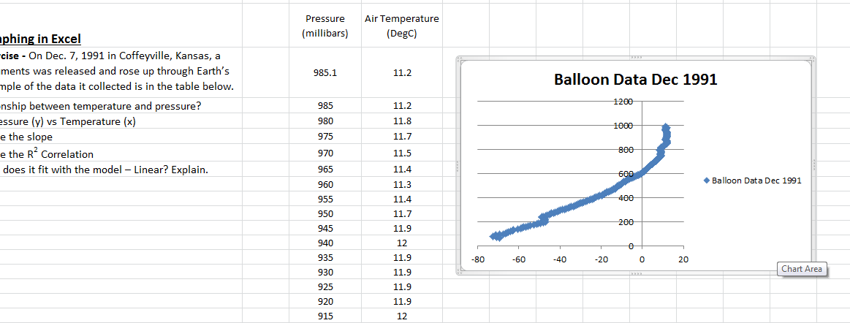

- Make the graph large by expanding the graph to make it easier to view.

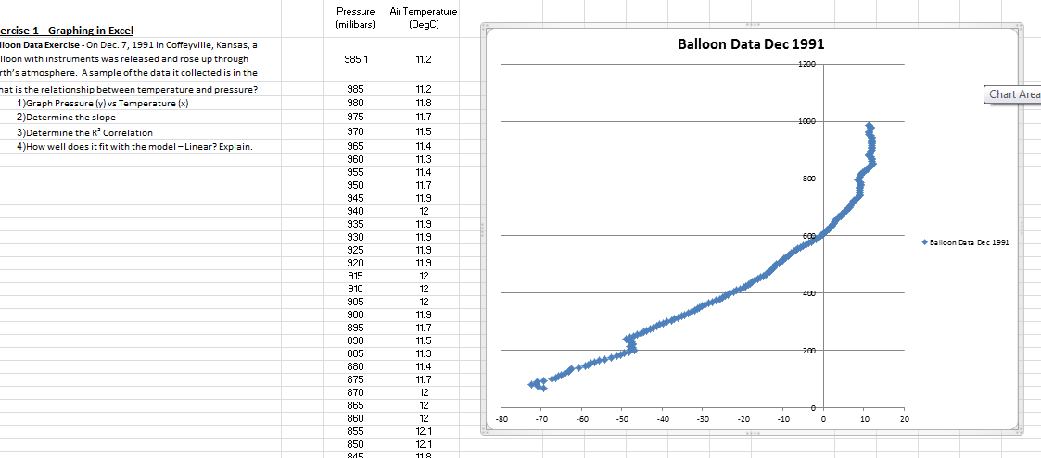

- To move the vertical axis to the left of the page, right click on horizontal axis of the graph and select “format axis”
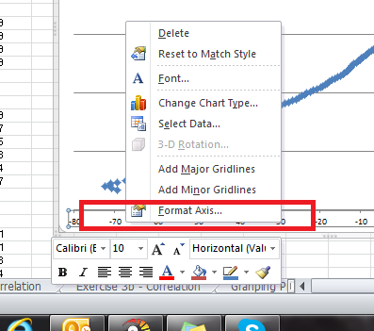
- Under the “Vertical axis crosses”, select “Axis value” and set it to the left most data point which is -80 in this case.
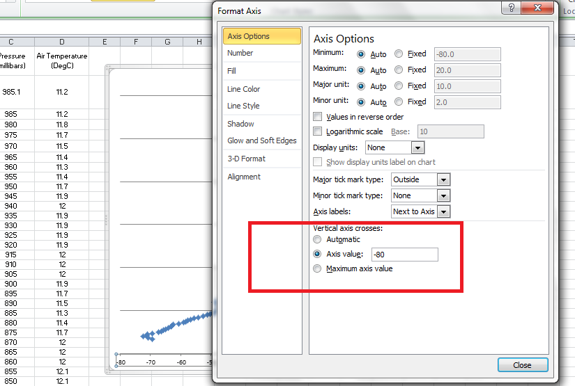
It should move the vertical axis to the left side like this:
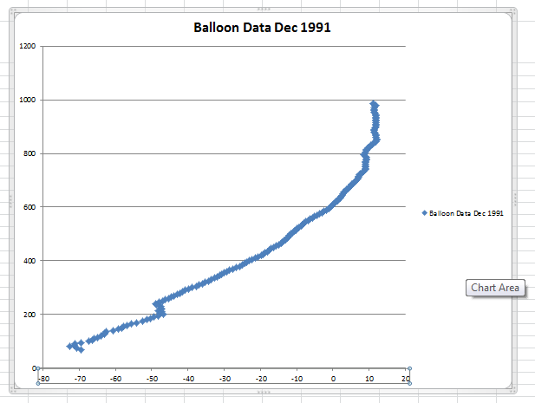

- Next, lets put axis titles, equation and R2 on the graph. The easiest way is to select the DESIGN tab and then the bottom arrow to select the chart type.
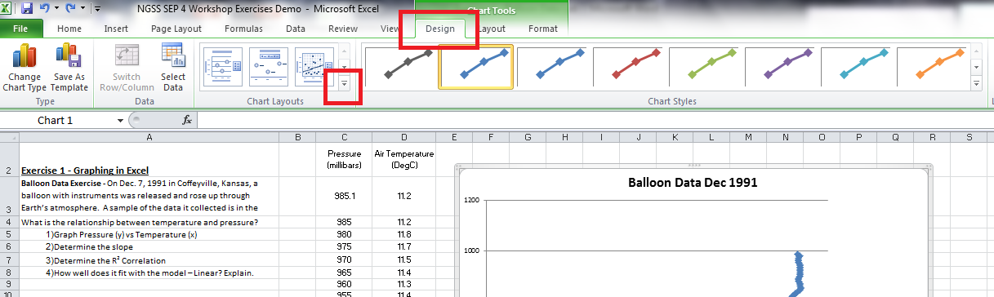

- Select the bottom right – Layout 9
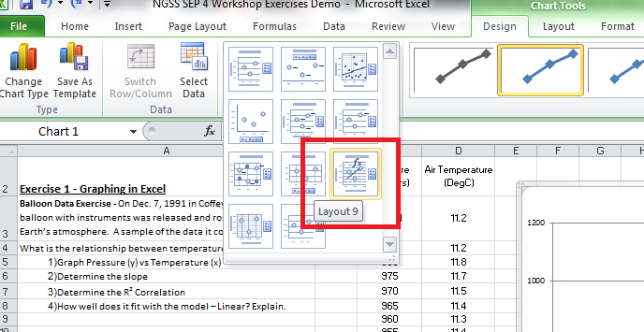
- It should display the following where you can click on the axis titles to change the names and the equation show is the linear fit and the R² value.
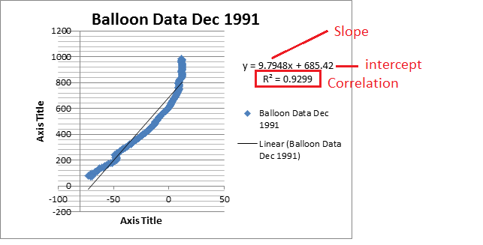

Alternative way to add chart axis titles and trendline

- To add chart titles, Click on the Layout Tab, Axis Titles, Primary Horizontal Axis Title, Axis Below to display the horizontal.
- Repeat for the Vertical Axis Titles
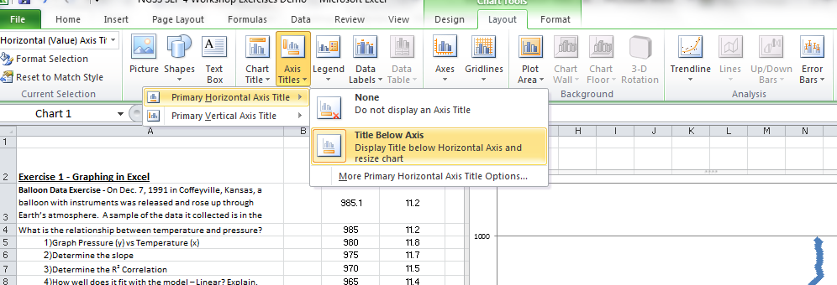

To add a trendline, equation and correlation:
- Right click on the data points Select Add Trendline
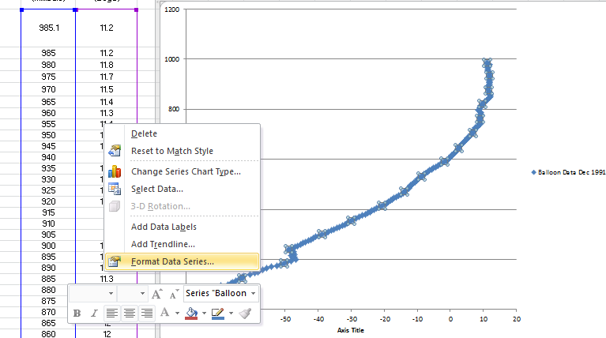

- Select the type of model/fit you would like to use. For this example, use the “Linear”.
- Check the box “Display Equation” and “Display R-Squared”
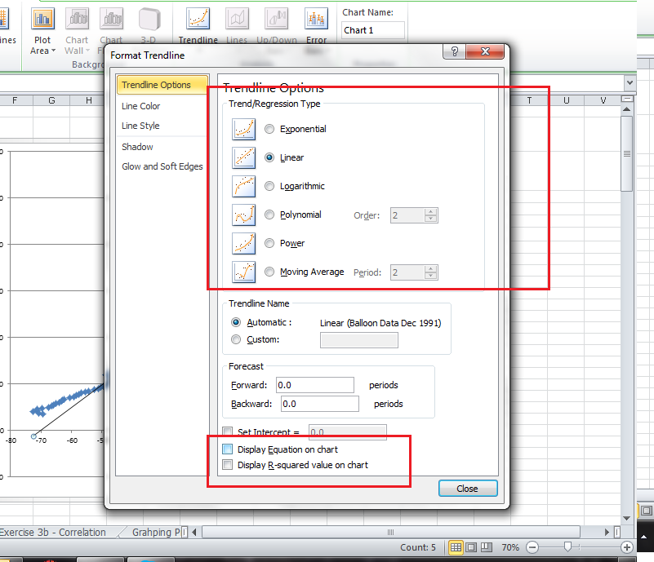

After labeling the graph, it should look like:
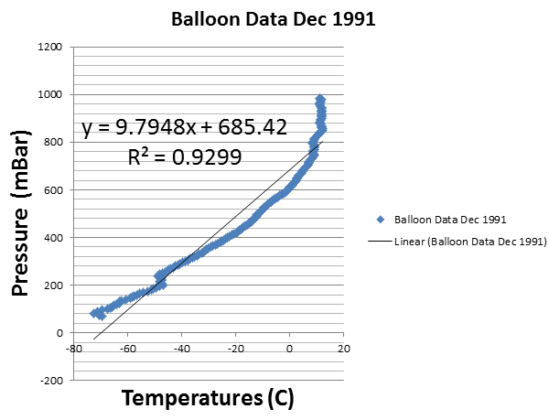

The trend line generates the best fit with the data give. From this,
Answer the following questions:
What is the relationship between temperature and pressure?
1)Graph Pressure (y) vs Temperature (x)
2)Determine the slope
3)Determine the R² Correlation
4)How well does it fit with the model – Linear? Explain.

Generate a list of questions you can ask your students with the data in this graph:

