Name: _______________________________________________ Date:________________________
Partners: _________________________________________________________________________

Standards: SEP1, SEP4, SEP8, CC3, HS-ESS2-5, MS-ESS2-5, CCW6.2., CCW7.2, CCW8.2, CC-RST6.8-7
Goals:
- Technical skill of plotting two different data sets on the same graph
- Determine the correlation coefficient between two data sets using the excel functions
Correlation Data Exercise – On the internet, there is a viral graph that relates global warming to the number of pirates. Using the data from the graph, you will generate an excel plot to verify if this relationship depicted on the graph is correlated using the correlation function on excel. In addition you will learn how to plot two different data sets on the same graph.
- What is the correlation between Pirates and Global Temperatures?
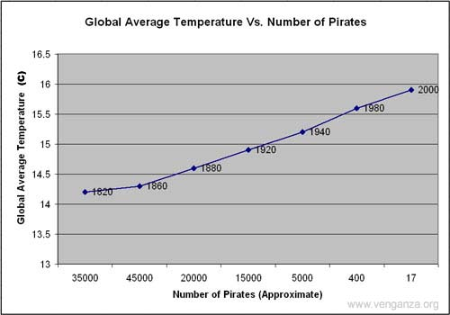
Procedure
- Open excel file – Exercise 3a
- Insert LINE GRAPH
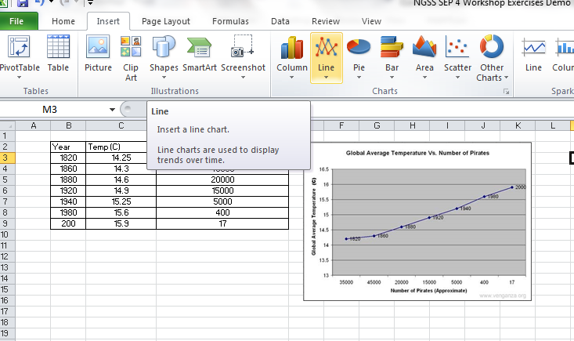

- Right click on the blank graph and Select Data
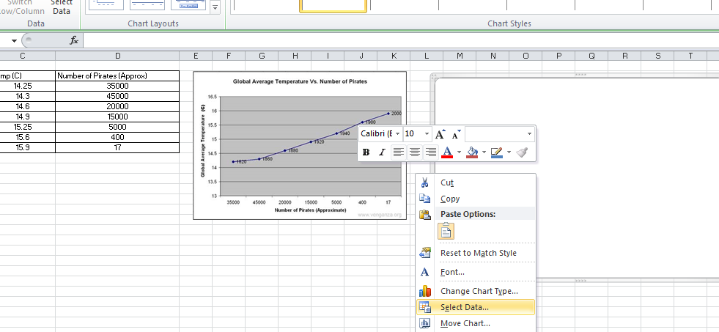

- Add Data:
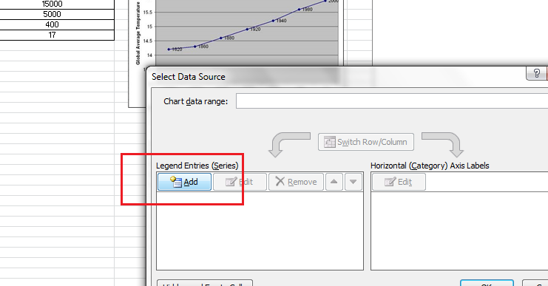

- For series name: Temp (C) and using the 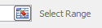 highlight the temperature values only (not titles or no units in data). Select OK when complete.
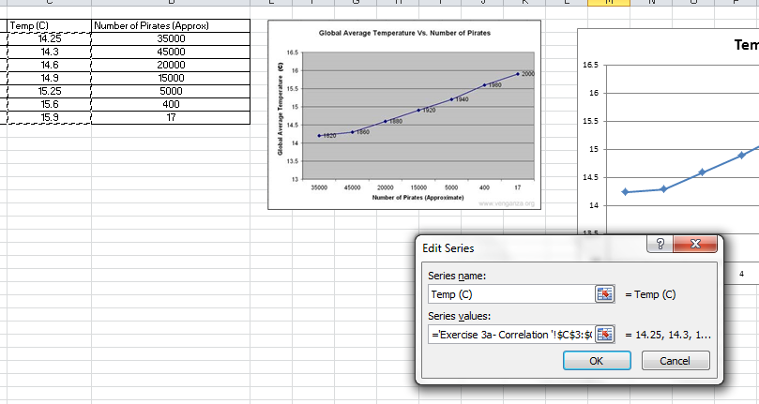

- Add another set of data. Select Add as in step 4, and then for series name: Number of Pirates and use the highlight the values only (not titles or no units in data). Select OK when complete.
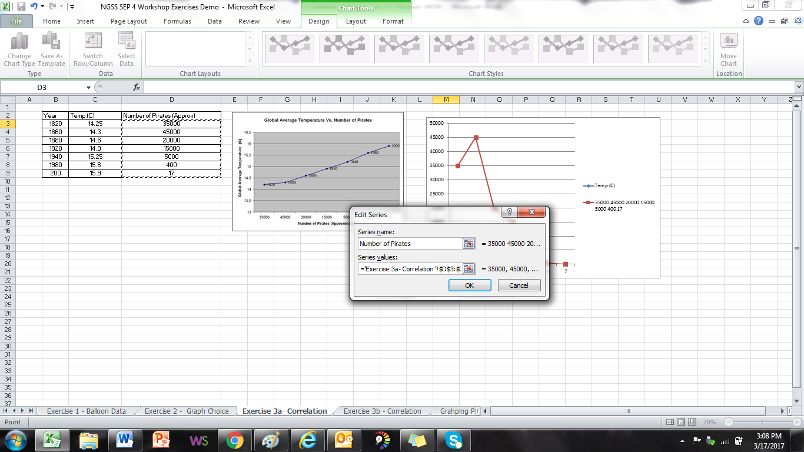

- Next, we want to edit the Horizontal Values to match the dates. Select Horizontal “EDIT”.
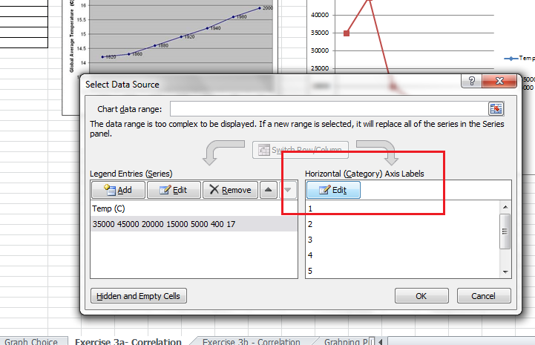

- Select the button and highlight the years

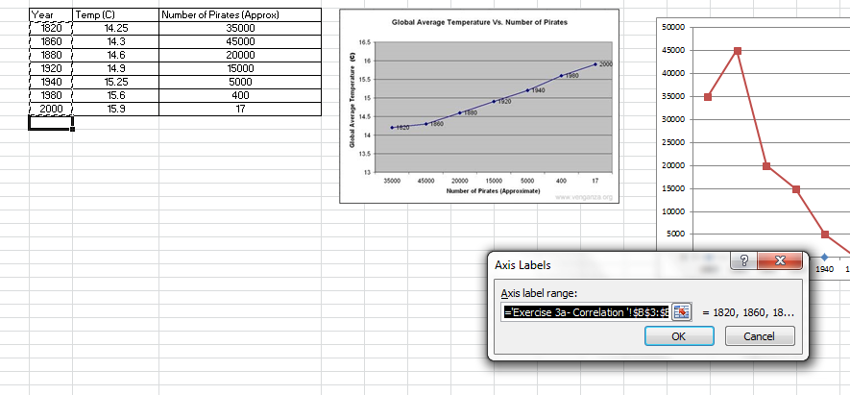

- Press OK when you are done and press OK again in the next screen to return to the excel spreadsheet.
- To display both vertical axis, right click on the temperature data series (the line on the bottom of the graph) and select FORMAT DATA SERIES

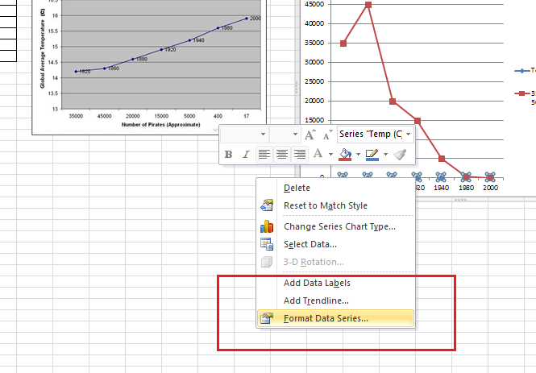

- Under Series Options, select Secondary Axis:
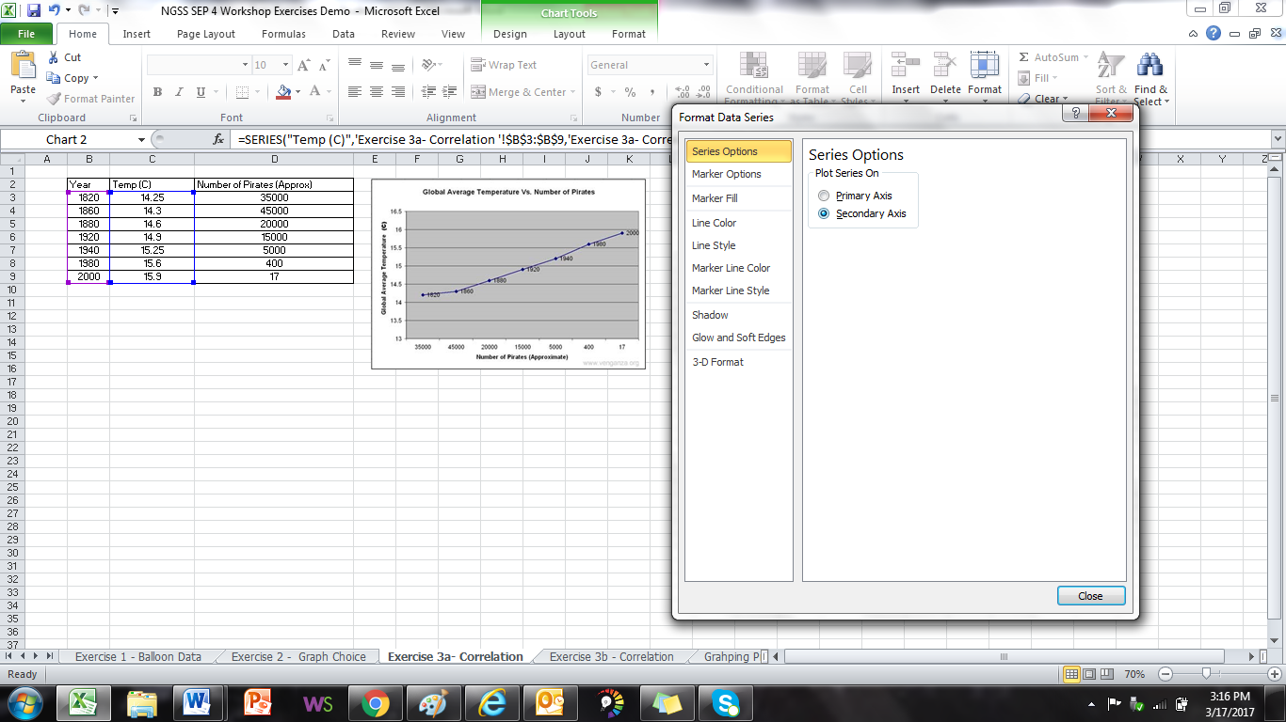

- You should now see both data series axis on the same plot. Next we will flip one of the data sets to generate a similar looking trend for both plots. ** You can add axis labels using the methods in Exercise 1.
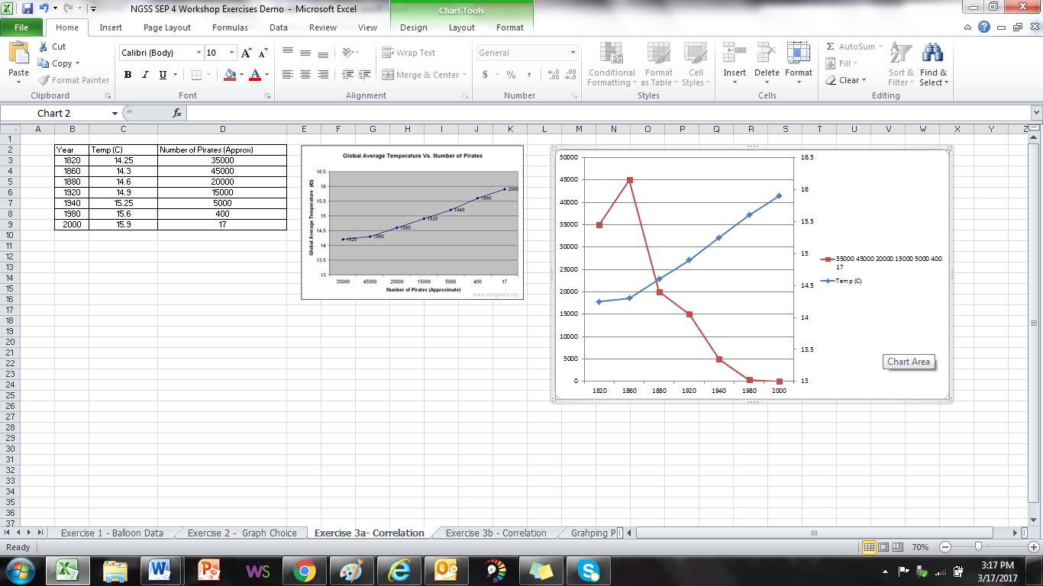

- Right click on the right vertical axis and select FORMAT AXIS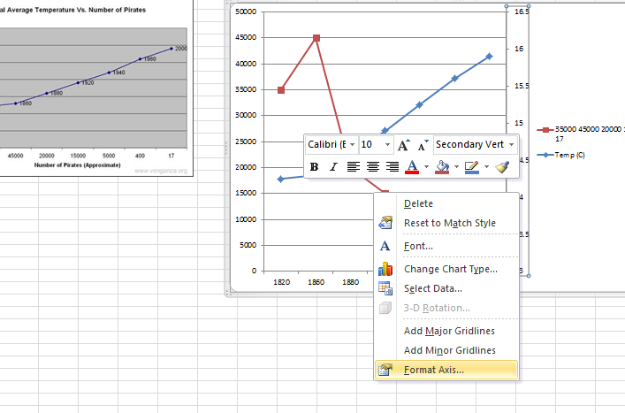

- Next, Select Values in Reserve Order, this will flip the axis and data set.

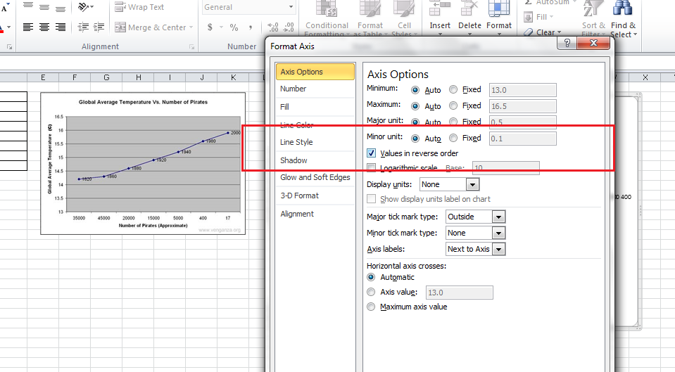

- It should now look like this:
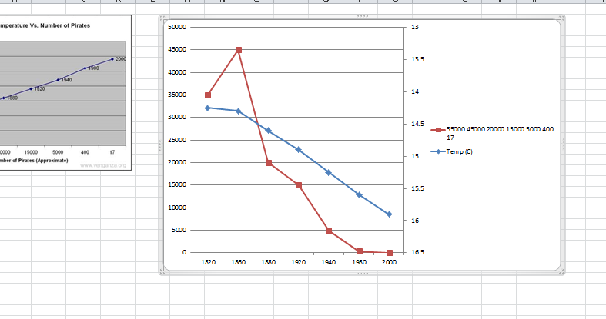

- Add trendlines, equations and R2 to each trendline. In addition add chart titles, etc.

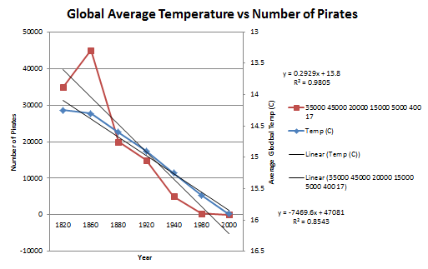

- From this, one can discuss the trendlines, R2, slope, etc. Note, the correlations for each trendline is a correlation of the data within the data sets themselves, and not with one another.

- Now to calculate the correlation between the two data sets using the CORREL function in excel. In a blank cell anywhere on your spreadsheet, type in =CORREL . When you do, excel will ask to use its function CORREL. The equation sign is important because this communicates to excel that you want to use a function/calculation.

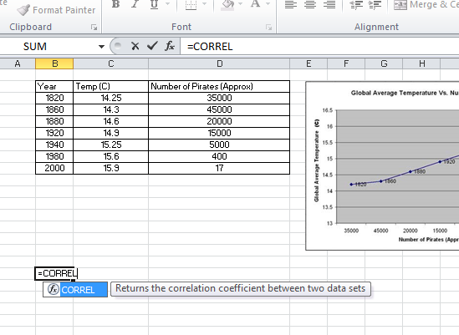

- Select the function. If you do it properly, it should look like this:
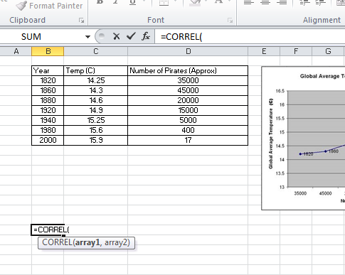
Array 1 = first data set
Array 2 = second data set

- Select all of the temperature values of the first data set
- Type a “, “ after you select the first data set to separate the array and to select the next set of data. Select the number of pirates next.

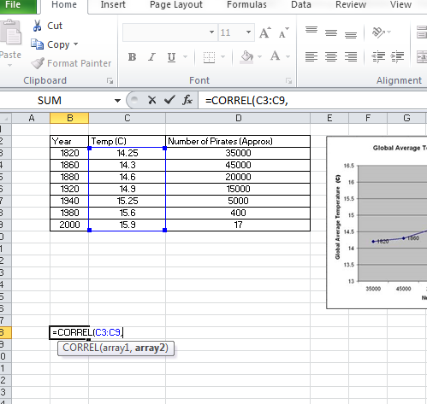

The color of the highlighted cell should coordinate with the color of the arrays in the equation.

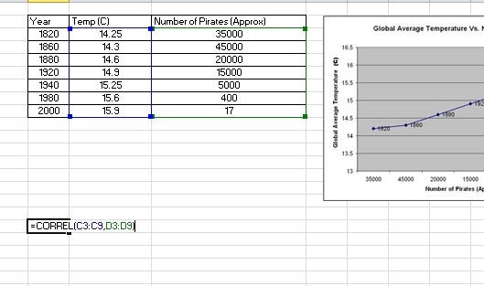

- Finally type a “)” to close the function and press ENTER to process the equation. When you do, it should leave with just a number. Add the label “Correlation Coefficient” above the number to note the calculation.

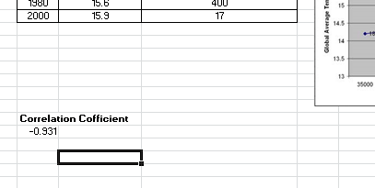

- Based on the Correlation Coefficient, pirates and temperature are highly correlated.

